**Самостоятельная работа**

Исходный код проекта:

<https://github.com/verkhoumov/AndroidLabs/tree/master/Layouts>

Скриншоты экрана:

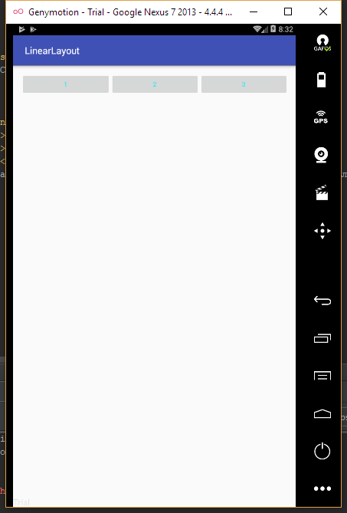

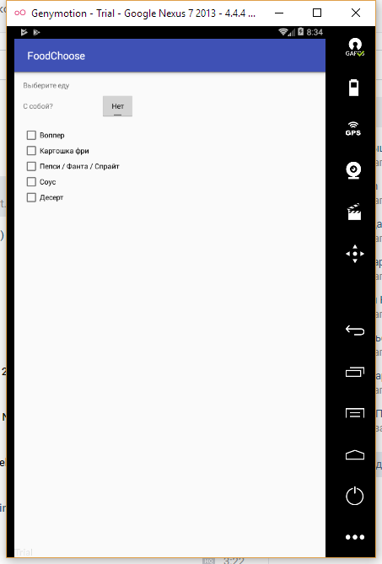

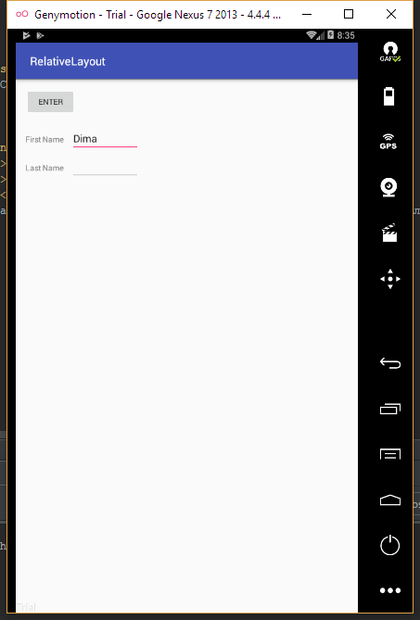

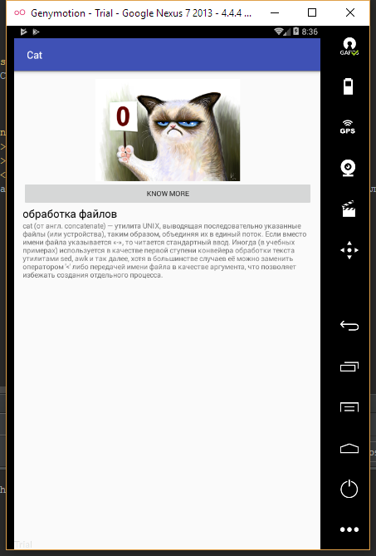

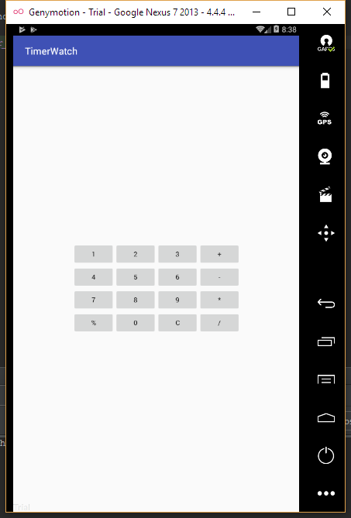

Исходный код.

activity_linear_layout.xml:

1. **<?xml** version="1.0" encoding="utf-8"**?>**
2. **<LinearLayout** xmlns:android="http://schemas.android.com/apk/res/android"
3. xmlns:tools="http://schemas.android.com/tools"
4. android:layout_width="match_parent"
5. android:layout_height="match_parent"
6. android:paddingBottom="@dimen/activity_vertical_margin"
7. android:paddingLeft="@dimen/activity_horizontal_margin"
8. android:paddingRight="@dimen/activity_horizontal_margin"
9. android:paddingTop="@dimen/activity_vertical_margin"
10. tools:context="ru.verkhoumov.layouts.LinearLayout"
11. android:baselineAligned="false"**>**
13. **<Button**
14. android:id="@+id/button"
15. android:layout_width="match_parent"
16. android:layout_height="wrap_content"
17. android:text="1"
18. android:textColor="#21ebf2"
19. android:layout_weight="1" **/>**
21. **<Button**
22. android:id="@+id/button2"
23. android:layout_width="match_parent"
24. android:layout_height="wrap_content"
25. android:text="2"
26. android:textColor="#21ebf2"
27. android:layout_weight="1" **/>**
29. **<Button**
30. android:id="@+id/button3"
31. android:layout_width="match_parent"
32. android:layout_height="wrap_content"
33. android:text="3"
34. android:textColor="#21ebf2"
35. android:layout_weight="1" **/>**
36. **</LinearLayout>**

activity_food_choose.xml:

1. **<?xml** version="1.0" encoding="utf-8"**?>**
2. **<RelativeLayout** xmlns:android="http://schemas.android.com/apk/res/android"
3. xmlns:tools="http://schemas.android.com/tools"
4. android:layout_width="match_parent"
5. android:layout_height="match_parent"
6. android:paddingBottom="@dimen/activity_vertical_margin"
7. android:paddingLeft="@dimen/activity_horizontal_margin"
8. android:paddingRight="@dimen/activity_horizontal_margin"
9. android:paddingTop="@dimen/activity_vertical_margin"
10. tools:context="ru.verkhoumov.layouts.FoodChoose"**>**
12. **<TextView**
13. android:id="@+id/choose_food"
14. android:layout_width="wrap_content"
15. android:layout_height="wrap_content"
16. android:text="@string/choose_food"
17. android:layout_alignParentTop="true"
18. android:layout_alignParentStart="true" **/>**
20. **<TextView**
21. android:id="@+id/takeaway"
22. android:layout_width="wrap_content"
23. android:layout_height="wrap_content"
24. android:text="@string/takeaway"
25. android:layout_alignTop="@+id/choose_food"
26. android:layout_alignParentStart="true"
27. android:layout_marginTop="40dp" **/>**
29. **<ToggleButton**
30. android:id="@+id/toggle"
31. android:layout_width="wrap_content"
32. android:layout_height="wrap_content"
33. android:textOn="@string/yes"
34. android:textOff="@string/no"
35. android:layout_alignStart="@+id/takeaway"
36. android:layout_alignBaseline="@+id/takeaway"
37. android:layout_marginStart="150dp" **/>**
39. **<CheckBox**
40. android:id="@+id/checkboxVopper"
41. android:layout_width="wrap_content"
42. android:layout_height="wrap_content"
43. android:text="@string/food_vopper"
44. android:layout_alignTop="@+id/takeaway"
45. android:layout_alignParentStart="true"
46. android:layout_marginTop="50dp" **/>**
48. **<CheckBox**
49. android:id="@+id/checkboxPotatos"
50. android:layout_width="wrap_content"
51. android:layout_height="wrap_content"
52. android:text="@string/food_potatos"
53. android:layout_alignTop="@+id/checkboxVopper"
54. android:layout_alignStart="@+id/checkboxVopper"
55. android:layout_marginTop="30dp" **/>**
57. **<CheckBox**
58. android:id="@+id/checkboxDrink"
59. android:layout_width="wrap_content"
60. android:layout_height="wrap_content"
61. android:text="@string/food_drink"
62. android:layout_alignTop="@+id/checkboxPotatos"
63. android:layout_alignStart="@+id/checkboxVopper"
64. android:layout_marginTop="30dp" **/>**
66. **<CheckBox**
67. android:id="@+id/checkboxSouce"
68. android:layout_width="wrap_content"
69. android:layout_height="wrap_content"
70. android:text="@string/food_souce"
71. android:layout_alignTop="@+id/checkboxDrink"
72. android:layout_alignStart="@+id/checkboxVopper"
73. android:layout_marginTop="30dp" **/>**
75. **<CheckBox**
76. android:id="@+id/checkboxDesert"
77. android:layout_width="wrap_content"
78. android:layout_height="wrap_content"
79. android:text="@string/food_desert"
80. android:layout_alignTop="@+id/checkboxSouce"
81. android:layout_alignStart="@+id/checkboxVopper"
82. android:layout_marginTop="30dp" **/>**
83. **</RelativeLayout>**

activity_relative_layout.xml:

1. **<?xml** version="1.0" encoding="utf-8"**?>**
2. **<RelativeLayout** xmlns:android="http://schemas.android.com/apk/res/android"
3. xmlns:tools="http://schemas.android.com/tools"
4. android:layout_width="match_parent"
5. android:layout_height="match_parent"
6. android:paddingBottom="@dimen/activity_vertical_margin"
7. android:paddingLeft="@dimen/activity_horizontal_margin"
8. android:paddingRight="@dimen/activity_horizontal_margin"
9. android:paddingTop="@dimen/activity_vertical_margin"
10. tools:context="ru.verkhoumov.layouts.RelativeLayout"**>**
12. **<Button**
13. android:id="@+id/button"
14. android:layout_width="wrap_content"
15. android:layout_height="wrap_content"
16. android:text="@string/enter"
17. android:layout_alignParentTop="true"
18. android:layout_alignParentStart="true" **/>**
20. **<TextView**
21. android:id="@+id/firstname"
22. android:layout_width="wrap_content"
23. android:layout_height="wrap_content"
24. android:text="@string/first_name"
25. android:layout_alignTop="@+id/button"
26. android:layout_alignParentStart="true"
27. android:layout_marginTop="80dp" **/>**
29. **<EditText**
30. android:id="@+id/editFirstname"
31. android:layout_width="wrap_content"
32. android:layout_height="wrap_content"
33. android:layout_alignStart="@+id/firstname"
34. android:layout_alignBaseline="@+id/firstname"
35. android:layout_marginStart="80dp"
36. android:width="120dp" **/>**
38. **<TextView**
39. android:id="@+id/lastname"
40. android:layout_width="wrap_content"
41. android:layout_height="wrap_content"
42. android:text="@string/last_name"
43. android:layout_alignTop="@+id/firstname"
44. android:layout_alignParentStart="true"
45. android:layout_marginTop="50dp" **/>**
47. **<EditText**
48. android:id="@+id/editLastname"
49. android:layout_width="wrap_content"
50. android:layout_height="wrap_content"
51. android:layout_alignStart="@+id/lastname"
52. android:layout_alignBaseline="@+id/lastname"
53. android:layout_marginStart="80dp"
54. android:width="120dp" **/>**
55. **</RelativeLayout>**

activity_cat.xml:

1. **<?xml** version="1.0" encoding="utf-8"**?>**
2. **<GridLayout** xmlns:android="http://schemas.android.com/apk/res/android"
3. xmlns:tools="http://schemas.android.com/tools"
4. android:layout_width="match_parent"
5. android:layout_height="match_parent"
6. android:paddingBottom="@dimen/activity_vertical_margin"
7. android:paddingLeft="@dimen/activity_horizontal_margin"
8. android:paddingRight="@dimen/activity_horizontal_margin"
9. android:paddingTop="@dimen/activity_vertical_margin"
10. tools:context="ru.verkhoumov.layouts.Cat"
11. android:weightSum="1"**>**
13. **<ImageView**
14. android:layout_width="300dp"
15. android:layout_height="200dp"
16. android:id="@+id/cat"
17. android:layout_gravity="center_horizontal"
18. android:src="@drawable/cat"
19. android:layout_row="0"
20. android:layout_column="0" **/>**
22. **<Button**
23. android:layout_width="match_parent"
24. android:layout_height="wrap_content"
25. android:text="@string/know_more"
26. android:id="@+id/button"
27. android:layout_row="1"
28. android:layout_column="0" **/>**
30. **<TextView**
31. android:layout_width="wrap_content"
32. android:layout_height="wrap_content"
33. android:text="@string/title_text"
34. android:id="@+id/title"
35. android:layout_row="2"
36. android:layout_column="0"
37. android:textSize="21sp"
38. android:textColor="#000000" **/>**
40. **<TextView**
41. android:layout_width="wrap_content"
42. android:layout_height="wrap_content"
43. android:id="@+id/description"
44. android:layout_row="3"
45. android:layout_column="0"
46. android:text="@string/description_text" **/>**
47. **</GridLayout>**

activity_timer_watch.xml:

1. **<?xml** version="1.0" encoding="utf-8"**?>**
2. **<GridLayout** xmlns:android="http://schemas.android.com/apk/res/android"
3. xmlns:tools="http://schemas.android.com/tools"
4. android:layout_width="wrap_content"
5. android:layout_height="wrap_content"
6. android:rowCount="12"
7. android:columnCount="4"
8. android:layout_gravity="center"
9. tools:context="ru.verkhoumov.layouts.TimerWatch"**>**
10. **<Button** android:text="1" **/>**
11. **<Button** android:text="2" **/>**
12. **<Button** android:text="3" **/>**
13. **<Button** android:text="+" **/>**
14. **<Button** android:text="4" **/>**
15. **<Button** android:text="5" **/>**
16. **<Button** android:text="6" **/>**
17. **<Button** android:text="-" **/>**
18. **<Button** android:text="7" **/>**
19. **<Button** android:text="8" **/>**
20. **<Button** android:text="9" **/>**
21. **<Button** android:text="*" **/>**
22. **<Button** android:text="%" **/>**
23. **<Button** android:text="0" **/>**
24. **<Button** android:text="C" **/>**
25. **<Button** android:text="/" **/>**
26. **</GridLayout>**